**Practical No:08**

**Events: Write programs to demonstrate the following events:**

1. **KeyEvent**

**Code:**

import javax.swing.*;

import java.awt.*;

import java.awt.event.*;

class Demo extends JFrame implements KeyListener

{

JLabel l;

JTextField t;

Demo()

{

setVisible(true);

setSize(400, 500);

setDefaultCloseOperation(JFrame.EXIT_ON_CLOSE);

setLayout(new FlowLayout());

t = new JTextField(10);

l = new JLabel();

add(t);

add(l);

t.addKeyListener(this);

}

public void keyPressed(KeyEvent e)

{

l.setText("Enter string...");

}

public void keyTyped(KeyEvent e)

{

l.setText("Typing...");

}

public void keyReleased(KeyEvent e)

{

String text = t.getText().trim();

if (text.isEmpty())

{

l.setText("Word count: 0");

}

else

{

String[] words = text.split(" ");

int count = words.length;

l.setText("Word count: " + count);

}

}

public static void main(String args[])

{

new Demo();

}

}

**Output:**

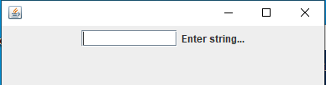

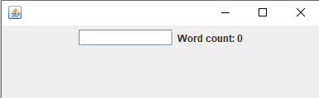

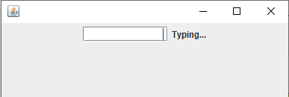

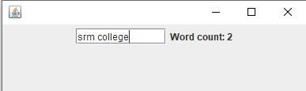

1. **MouseEvent**
2. **MouseListener**

**Code:**

import java.util.*;

import javax.swing.*;

import java.awt.*;

import java.awt.event.*;

class MouseE extends JFrame implements MouseListener

{

JLabel p;

JPanel l;

MouseE()

{

p=new JLabel();

l=new JPanel();

p.addMouseListener(this);

l.addMouseListener(this);

setSize(400,500);

setLayout(new BorderLayout());

setVisible(true);

add(p,BorderLayout.CENTER);

add(l,BorderLayout.CENTER);

}

public void mouseClicked(MouseEvent e)

{

p.setText("Mouse Clicked");

l.setBackground(Color.RED);

}

public void mousePressed(MouseEvent e)

{

p.setText("Mouse Pressed");

l.setBackground(Color.BLUE);

}

public void mouseEntered(MouseEvent e)

{

p.setText("Mouse Entered");

l.setBackground(Color.GREEN);

}

public void mouseExited(MouseEvent e)

{

p.setText("Mouse Exited");

l.setBackground(Color.WHITE);

}

public void mouseReleased(MouseEvent e)

{

p.setText("Mouse Released");

l.setBackground(Color.BLACK);

}

public static void main(String[] args)

{

MouseE m=new MouseE();

}

}

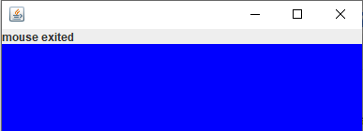**Output:**

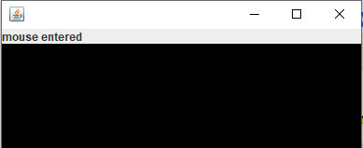

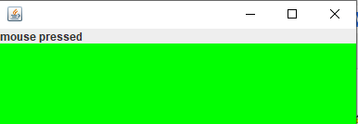

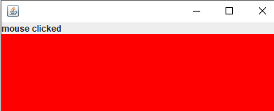

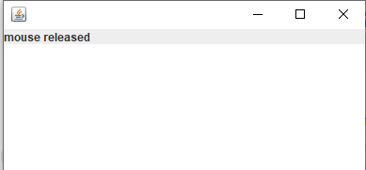

1. **MouseMotionListener**

**Code:**

import java.util.*;

import java.awt.event.*;

import java.awt.*;

import javax.swing.*;

class MML extends JFrame implements MouseMotionListener

{

JLabel l;

MML()

{

l=new JLabel();

setSize(400,500);

setLayout( new FlowLayout());

setVisible(true);

setDefaultCloseOperation(JFrame.EXIT_ON_CLOSE);

add(l);

addMouseMotionListener(this);

}

public void mouseDragged(MouseEvent e)

{

Graphics g=getGraphics();

g.setColor(Color.RED);

g.fillOval(e.getX(),e.getY(),20,20);

}

public void mouseMoved (MouseEvent e)

{

l.setText("X:"+e.getX()+"Y:"+e.getY());

}

public static void main(String args[])

{

new MML();

}

}

**Output:**

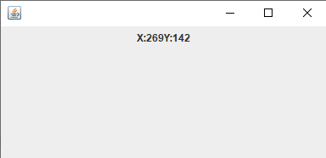

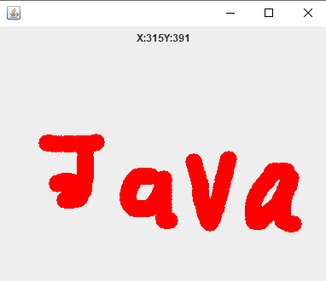

1. **FocusEvent**

**Code:**

import javax.swing.*;

import java.awt.*;

import java.awt.event.*;

import java.util.*;

class focus extends JFrame implements FocusListener{

JLabel l1,l2,l3;

JButton b;

JTextField f1,f2;

focus(){

l1=new JLabel("Username: ");

f1=new JTextField(10);

l2=new JLabel("Password: ");

f2=new JTextField(10);

l3=new JLabel();

b=new JButton("Submit");

f1.addFocusListener(this);

f2.addFocusListener(this);

add(l1);

add(f1);

add(l2);

add(f2);

add(l3);

add(b);

setLayout(new FlowLayout());

setVisible(true);

setSize(400,400);

setDefaultCloseOperation(JFrame.EXIT_ON_CLOSE);

}

public void focusGained(FocusEvent e){

if(e.getSource()==f2)

{

if(f1.getText().trim().isEmpty())

{

l3.setText("Username is required before password");

}

}

}

public void focusLost(FocusEvent e){

if(e.getSource()==f2)

{

l3.setText("");

}

}

public static void main(String[] args){

new focus();

}

}

**Output:**

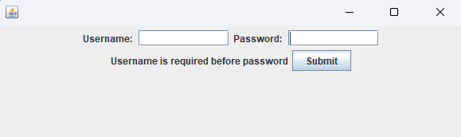

1. **SelectionEvent**

**Code:**

import javax.swing.*;

import java.awt.*;

import java.awt.event.*;

import java.util.*;

import javax.swing.event.*;

class selection extends JFrame implements ListSelectionListener

{

JLabel l;

JList<String> list;

String lang[] = {"Python", "Java", "C", "CPP"};

String info[] = {

"Python is a high-level interpreted language",

"Java is a high-level programming language",

"C is an efficient, all-purpose programming language",

"Cpp is an object-oriented programming language"};

selection()

{

l = new JLabel("Select language: ");

list = new JList<String>(lang);

list.addListSelectionListener(this);

add(l);

add(list);

setVisible(true);

setSize(400, 400);

setLayout(new FlowLayout());

setDefaultCloseOperation(JFrame.EXIT_ON_CLOSE);

}

public void valueChanged(ListSelectionEvent e)

{

if (!e.getValueIsAdjusting())

{

int index = list.getSelectedIndex();

if (index >= 0)

{

JOptionPane.showMessageDialog("Language info", info[index]);

}

}

}

public static void main(String[] args)

{

new selection();

}

}

**Output:**

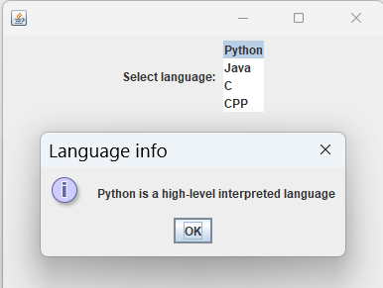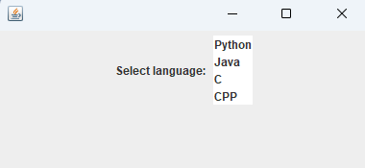

1. **ActionEvent**

**Code:**

import javax.swing.*;

import java.awt.*;

import java.*;

import java.awt.event.*;

class cube extends JFrame implements ActionListener

{

JLabel l1,l2;

JButton b;

JTextField t;

cube()

{

new JFrame("Calculator");

setSize(400,200);

setVisible(true);

setDefaultCloseOperation(JFrame.EXIT_ON_CLOSE);

setLayout(new FlowLayout());

l1=new JLabel("enter number");

add(l1);

t=new JTextField(10);

add(t);

b=new JButton("Cube");

add(b);

b.addActionListener(this);

l2=new JLabel();

add(l2);

}

public void actionPerformed(ActionEvent e)

{

String a=t.getText();

int b=Integer.parseInt(a);

int c=b*b*b;

l2.setText(Integer.toString(c));

}

public static void main(String args[])

{

new cube();

}

}

**Output:**

